<ProjID>HLD<Sr.No.> <Rel Date>



High-Level Design Document
(Software - OOAD)

<Ver.Rel>

EMB_TS_07F/5.1/07-Jul-17

DOCUMENT HISTORY

Ver.Rel. No | Release Date | Mod.By Mod. Dt | Rev. By  Relevant Stakeholders  Rev. Dt. | Auth By Auth Dt. | Remarks/Revision Details
1 | 19-11-2020 | Chethan G C

Table of contents

1. Project Details 3
2. High-Level Design 3
2.1 Scope and Overview 3
2.2 Design Strategy 3
2.3 Assumptions, Constraints & Limitations 3
2.4 Requirements Incomplete / Unclear items 3
2.5 Incomplete / unclear items for implementation 3
2.6 Applicable standards <if any> 3
3. System Architecture 4
3.1 Block Diagrams/Context Diagrams/Deployment diagram 4
3.2 Main Use Case Diagrams 4
3.3 Main Class Diagram 4
3.4 Memory Architecture and Data Integrity 4
3.5 Hardware Resource allocation 4
3.6 Interrupts 4
3.7 Task/module Scheduling and Task Priorities 4
3.8 Activity Diagram 4
3.9 Modules Section 4
4. Environment 5
4.1 Development Environment 5
4.2 Testing Environment 5
5. Critical items, Key characteristics, Product and Personal safety requirements 5
6. Appendix 5
6.1 Reference 5
6.2 Glossary of terms used 6
6.3 Glossary of symbols used 6

Project Details

Project ID | CES_SW_Shadow Project Proposal Ver 1.0 _Social_Influncer
Project Name | Social Influencer Web and Mobile Application

High-Level Design

Scope and Overview

- Creating a platform for the advertisers and the influencers for the product promotion
- Creating Android application for the Influncers
- Creating the web and android application for both web and influencers
- Usage of firebase cloud functions for hosting
- Usage of firebase hosting to host the website
- The android should contain the user-friendly UI.

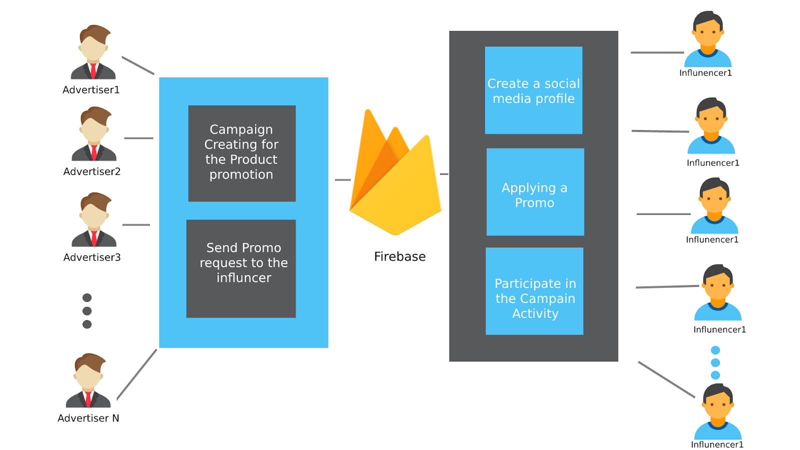

Design Strategy

- Design for Login and register other modules were referenced in google.
- Previous designs for the same kind of system is required.

Sl. No | Module Name / Module ID | Design criteria adopted | Design Decision  (R/B/I/IG)* | Version details for Bought out / Re-used modules | Rationale behind critical decisions
1 | Deployment | Modular | IG | - | -
2 | Use cases | Verifiable and testable | I | - | -
3 | Login Module | Modular and Verifiable | IG | - | -
4 | Register Module | Modular and Verifiable | IG | - | -
5 | Database usage Architecture | Testable and Verifiable | IG

Note: R – Reused from Organizational repository,
B – Bought out / COTS
I – Developed In-house
IG – Developed as a generic module for future use across the organization

Assumptions, Constraints & Limitations

- Assumption of social media profiles
- Assumption of advertisers campaign data.
- Assumption of the profile data.
- Fire base allows us to very less amount of resources under the free plan.
- The system even though system is scale able it takes lot of effort and cost to scale the system.

Requirements Incomplete / Unclear items

- The influencer profile details list is unclear.
- The Advertisers profile details list is unclear
- The database use is not clear because most of the data is J SON few times we might store images also proper database usage is unclear.

Incomplete / unclear items for implementation

- Search and Filter options designs are are not clear due to the unclear requirement.
- Can web application use the firebase project that is created for the android application.

Applicable standards

- NA

System Architecture

Block Diagrams/Context Diagrams/Deployment diagram

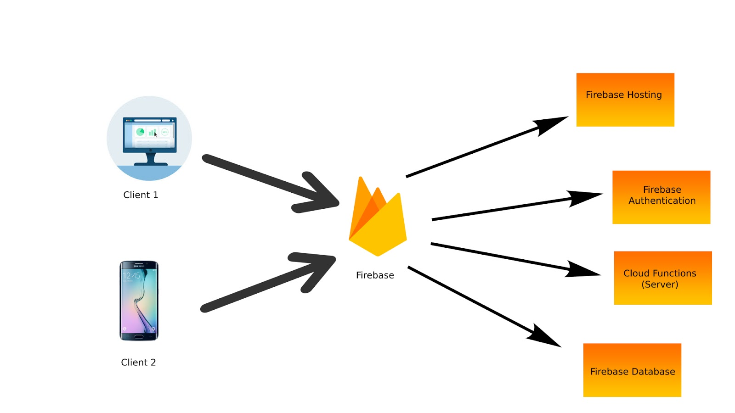
Client-server Interaction Block Diagram

The above figure shows the client server architecture of our project it uses the server-less architecture where there is not server maintained by the application creator. This will allow application creator to focus on the user experience not worrying about the scalability and other server related things.

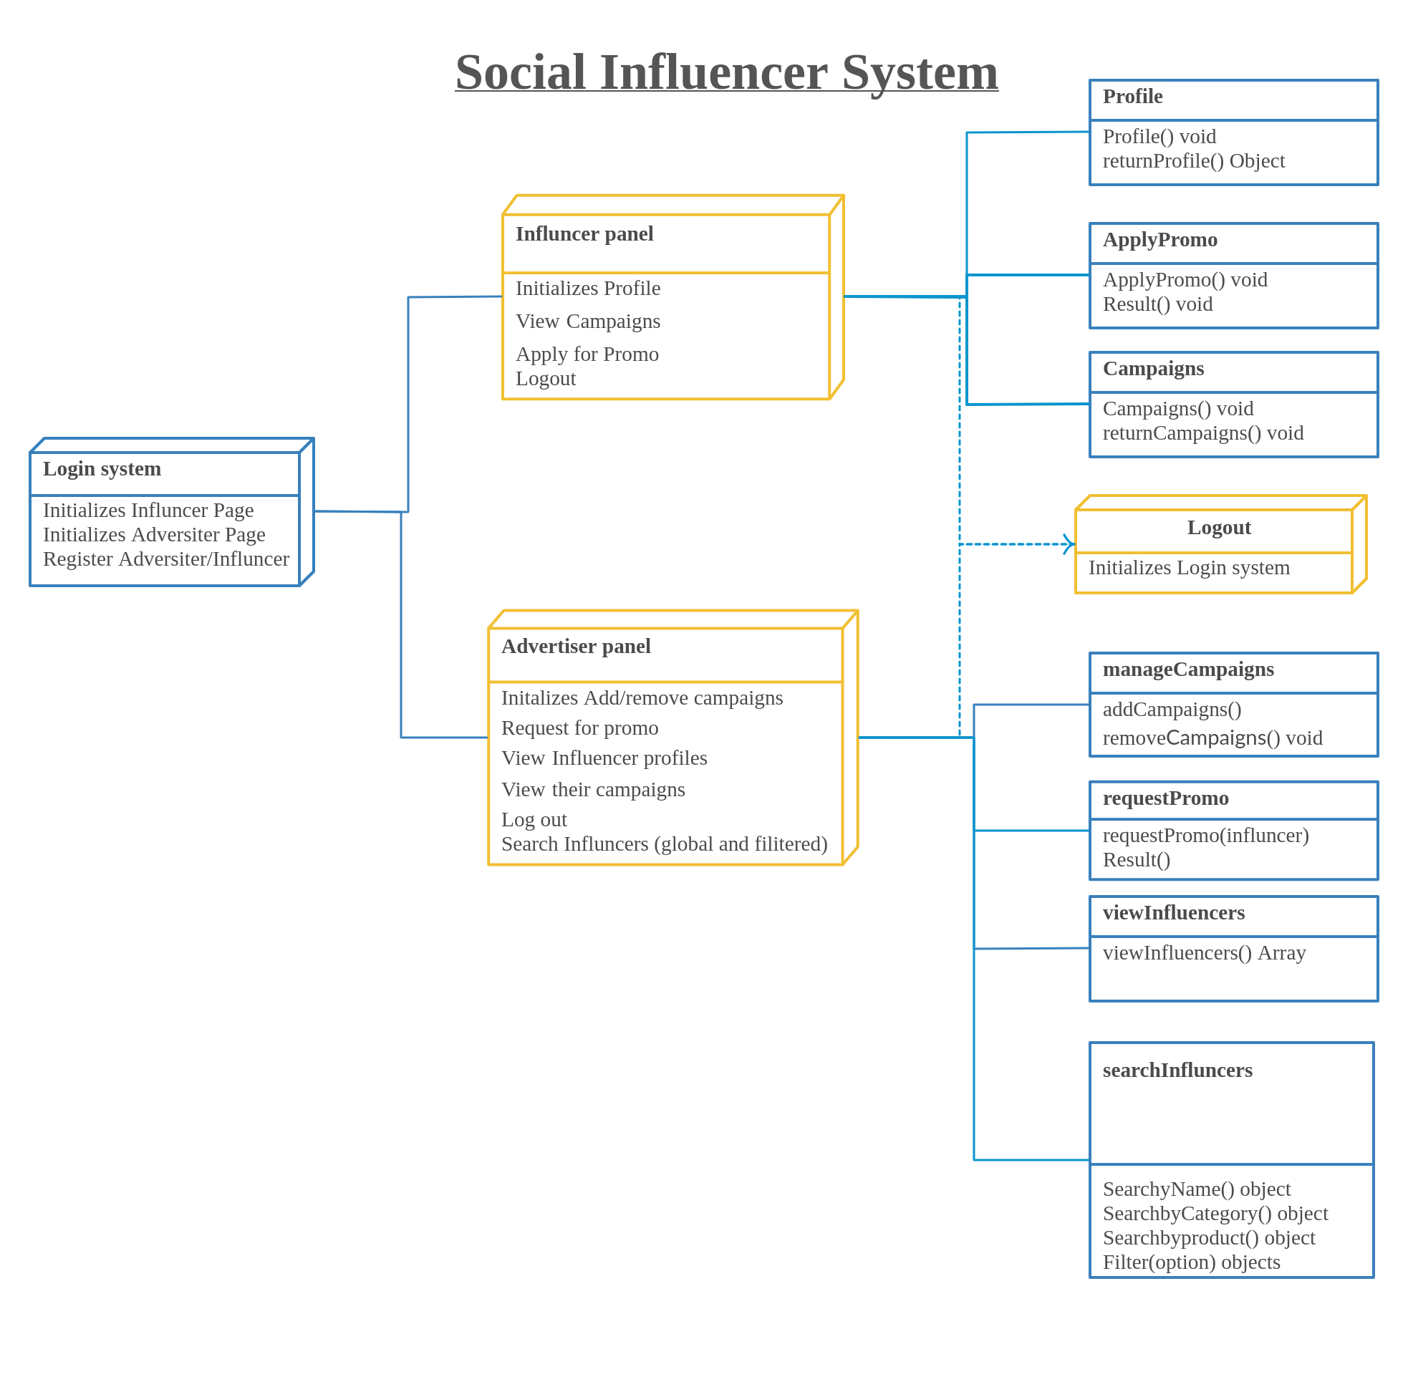
Deployment Diagram of the complete system

Main Use Case Diagrams

- Main Use case diagrams to show the input output interactions with the system by different stakeholders

Advertiser and System

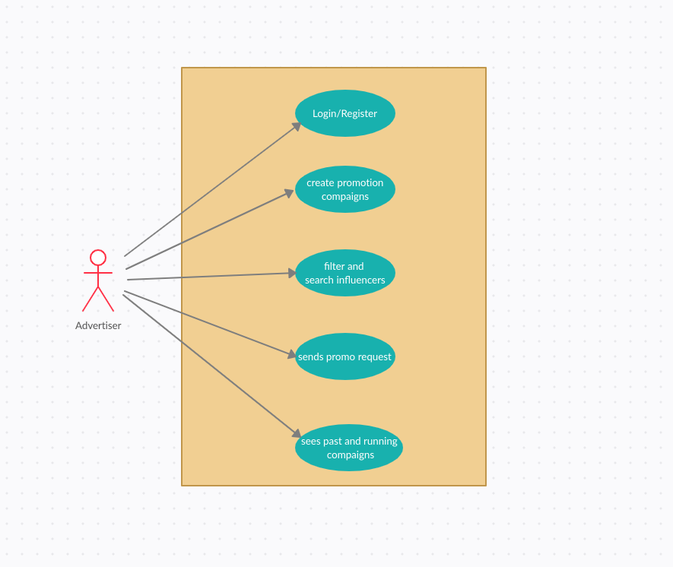

Influencer and System
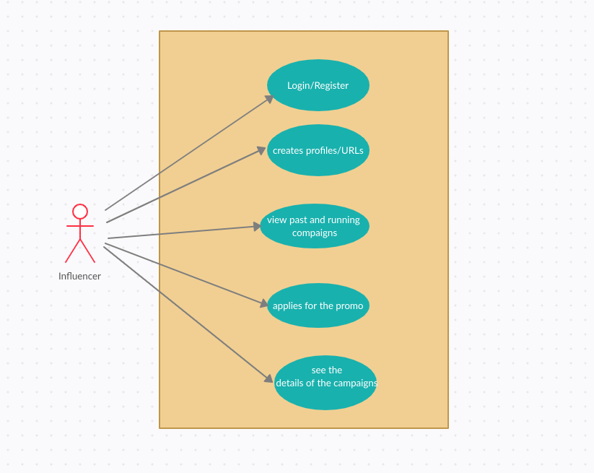

Complete System and stakeholders

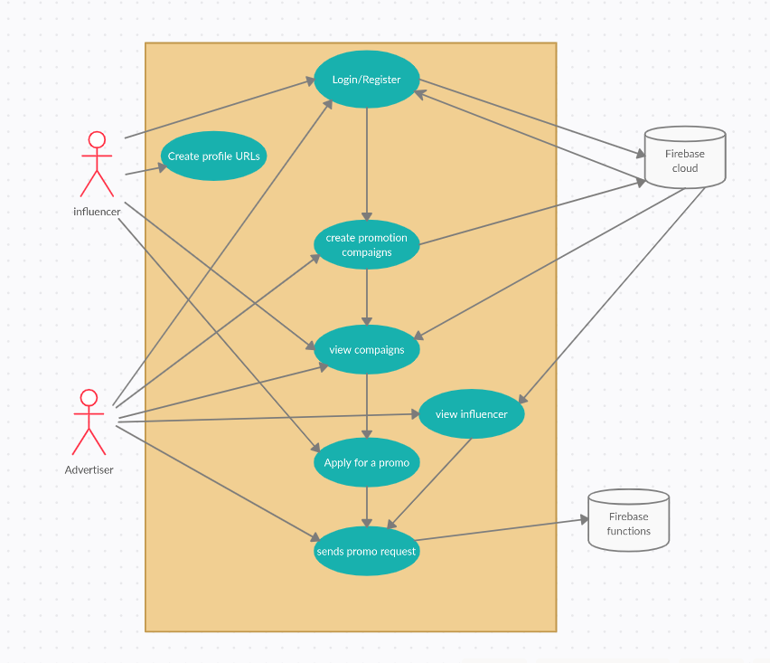

Main Class Diagram

- Class-diagram for the social influencer system is shown above.

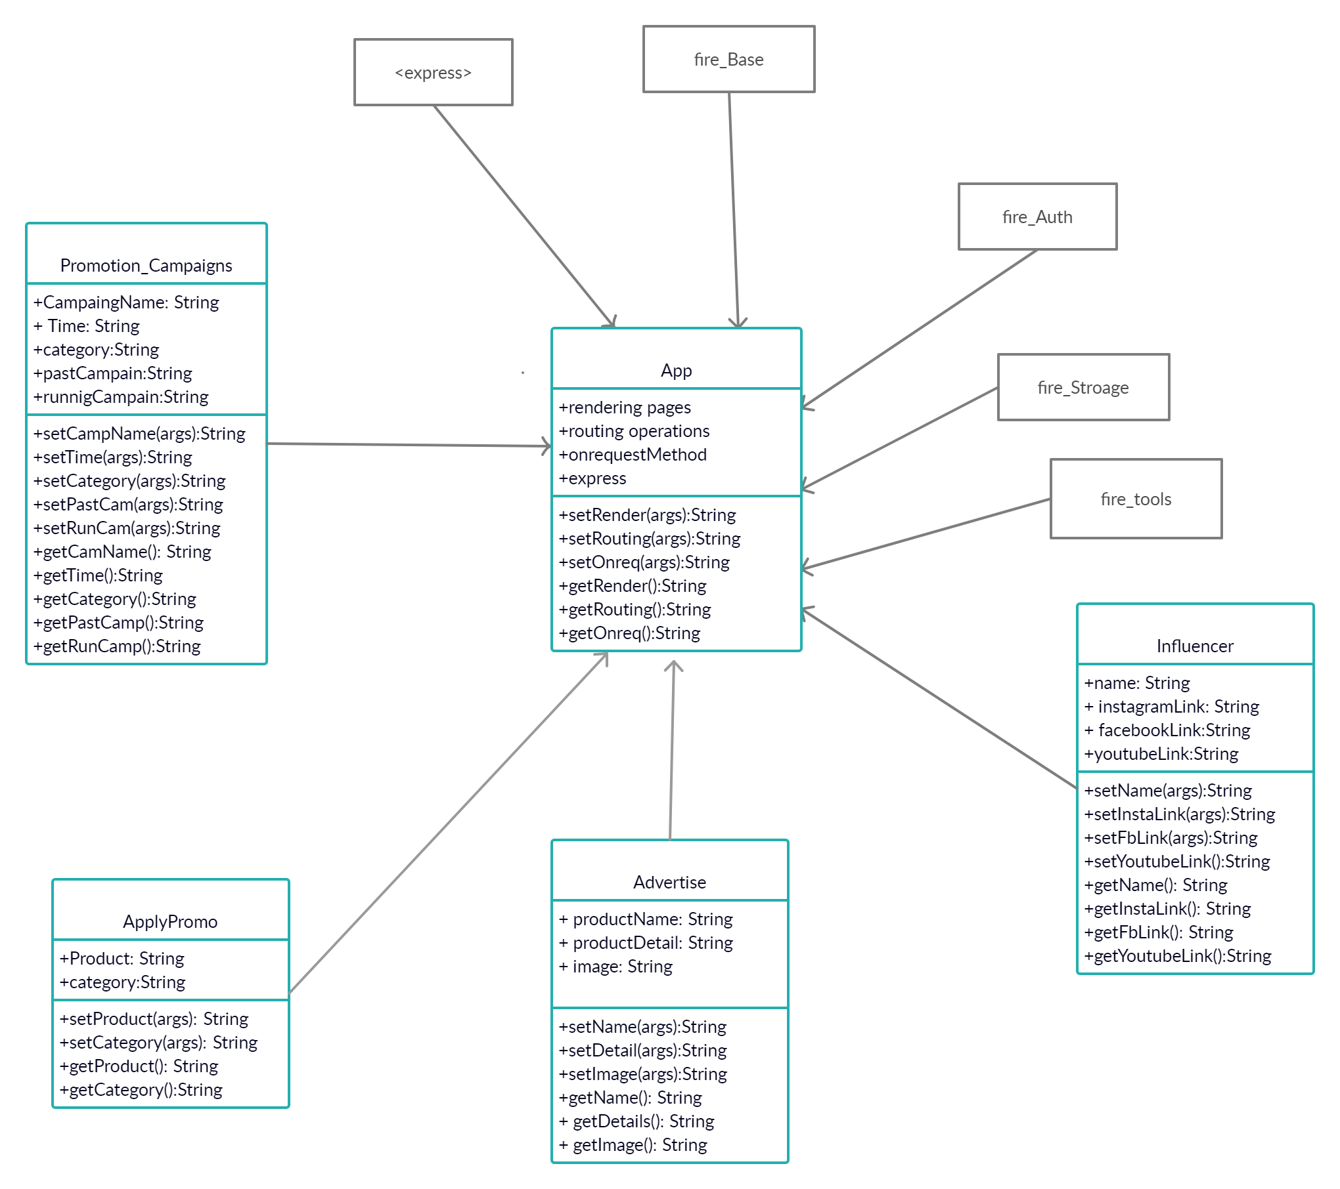

Memory Architecture and Data Integrity

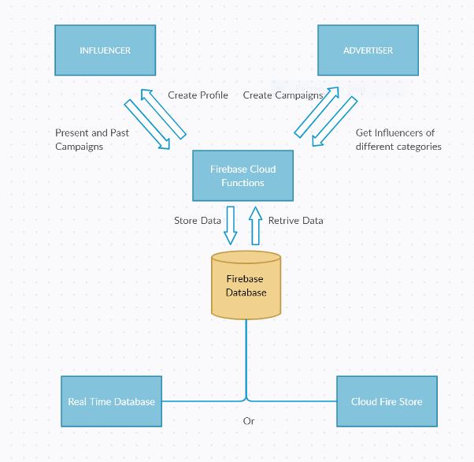
- Estimated memory resources are approx. 600MB
- ACID Properties are taken care by the firebase back end.

Hardware Resource allocation

- All hardware resources are maintained and allocated by the firebase using the sprak plan of the firebase

Interrupts
NA -No inter process communication in the system.

Task/module Scheduling and Task Priorities

- All the task list out is done in the excel sheet mentioned below
https://docs.google.com/spreadsheets/d/1a7Bzxx4NvlUCJ9exG1Q3x_6xQDZfNPIHPO4yej1C97w/edit?usp=sharing

Activity Diagram
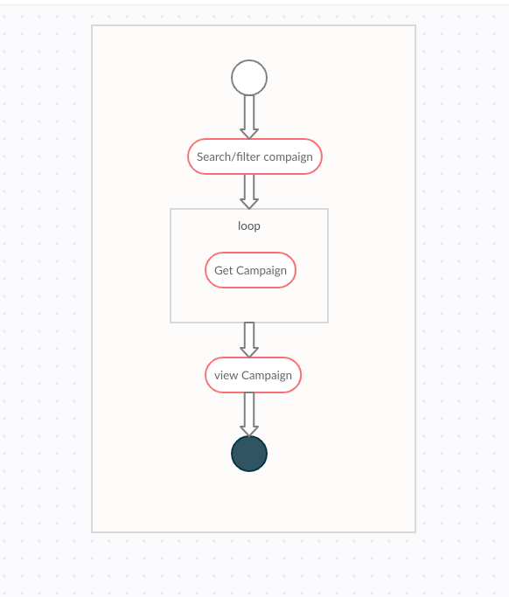

Search and filter campaign

Modules Section

<Login Module / Version 1.0>

Description
- Login module of the sytem

Diagrams

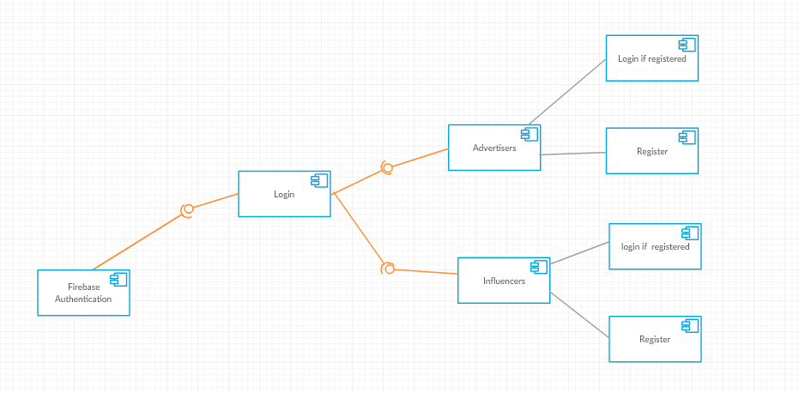

<Module 2 Register Module / Version No>

Description
- Registering the influncer and Advertisers.

Diagrams
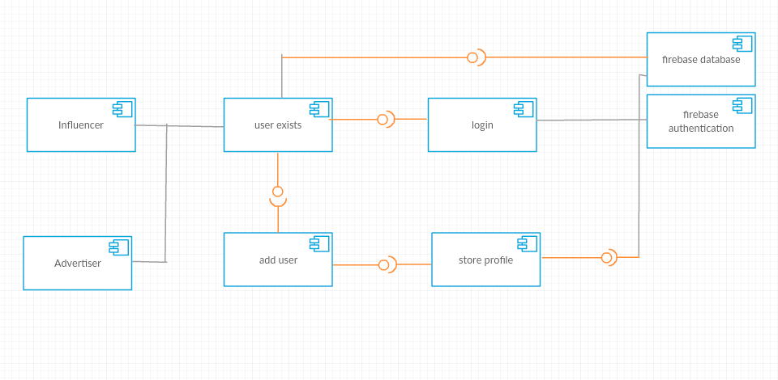

<Module 2 Applying Promo / Version No>

Description
- Applying a promo by the influencer

Diagrams
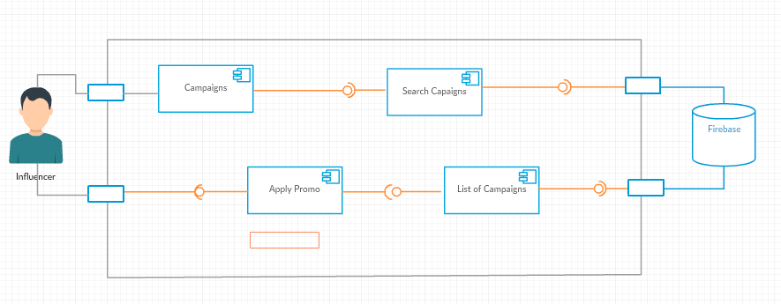

Environment

Development Environment
- Android phone
- Emulator
- Android studio
- Vs Code
- Firebase console
- Browser
- Node JS, HTMl, JS, JAVA

Testing Environment

- Postman to test the node API’s
- Selenium to test the web app Ui
- Junit for testing the android app UI and functions.

Critical items, Key characteristics, Product and Personal Safety requirements

Critical items –Firebase is the critical part if not properly use the whole project needs to setup from scratch

Key Characteristics – NA

Product and Personal Safety - NA

Sl. no. | Title of Critical item / Key characteristic/Safety Requirements | Category of critical item / Key Characteristic/Safety Requirements | Instructions for Specific actions to be taken on the Critical items / Key characteristics/Safety Requirements | References to design documents/drawings/DFMEA related to Critical items/Key characteristics/Safety Requirements
1 | Firebase | Cloud functions usage,  Database usage, hosting firebase | Use the Fire base for the better usage don't deploy frequently use it when ever it is required but use it minimal and test the application in the local environment before deploying. | NA

Appendix

Reference

- https://docs.google.com/spreadsheets/d/1a7Bzxx4NvlUCJ9exG1Q3x_6xQDZfNPIHPO4yej1C97w/edit?usp=sharing [Requirement Split Up]
- https://docs.google.com/document/d/1IlMPmVSR3RVM0EmmrnHfvgM-7vsn3gPP/edit?rtpof=true [Requirements]
- https://docs.google.com/document/d/1xf4PE8vbuwiwdQ8s73jn1DneVsrI2w8s/edit?rtpof=true [CES_SW_Shadow Project Proposal Ver 1.0 _Social_Influncer_Raghvendra]

Glossary of terms used

NA

Glossary of symbols used

NA

